Test PE  
SPRING 2021  
Subject: WED201c  
Duration: 120 minutes

**Objectives:**

1. Create a style sheet and link it to the html files.
2. Create a file named yourCode.js and link it to the html files.

**Background:**

In this practice exam, you are given a folder “**Resource**”. You are going to use page “index.html” to finish the exam.

**Before styling index.html page**

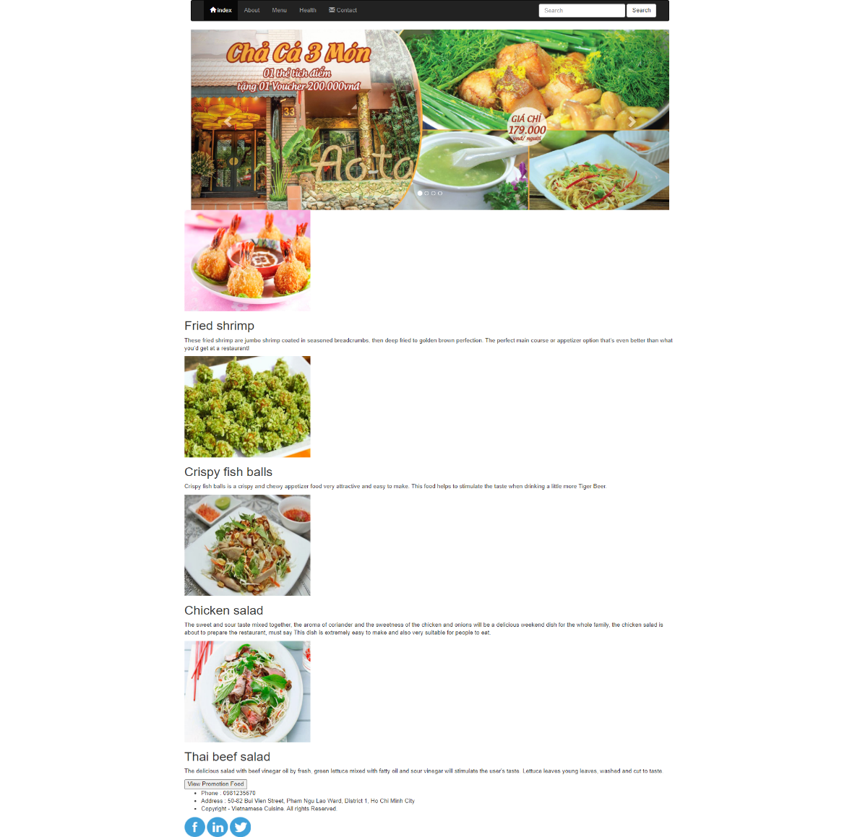

**After styling index.html page**

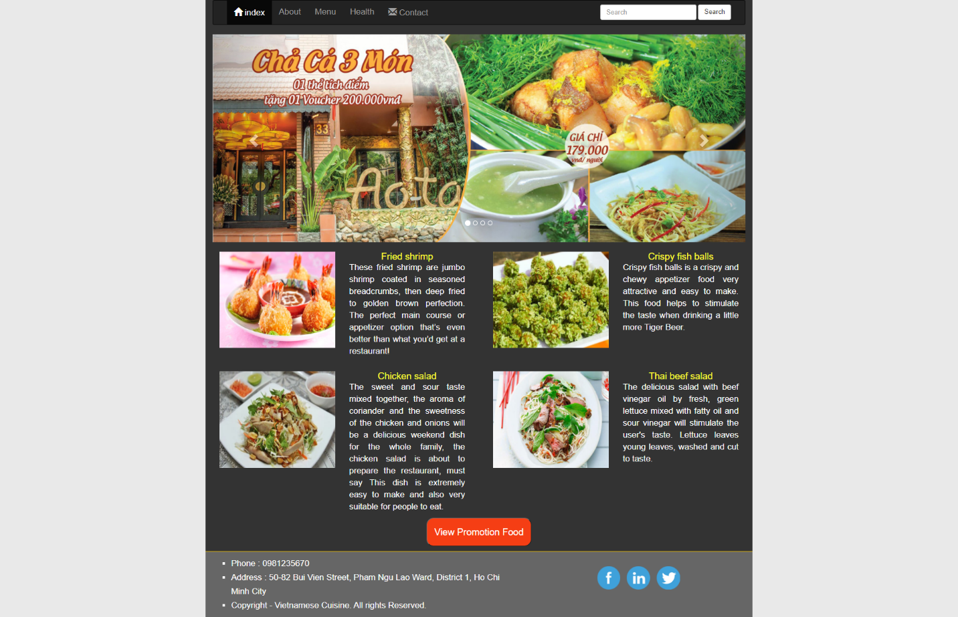

**The index.html page structure when users access by smartphone**

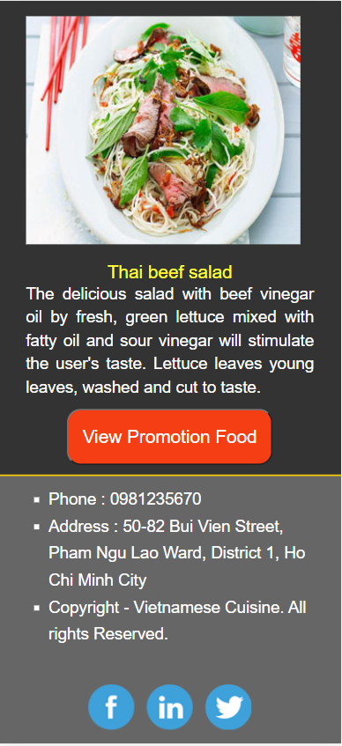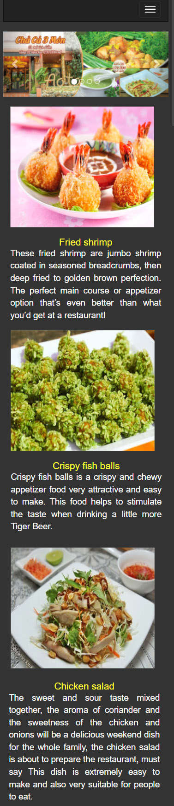

Scroll

**Required:**

1. Create a file called styleindex.css to format the index.html page and save it to the **Resource folder**.
2. Create a file called “mycode.js” and save it to the **Resource folder**. You must link this file to the index.html page.
3. Use css classes available in Bootstrap to format the content for index.html page.

**Evaluation**

**A. CSS [ 7 marks]**

* Use Bootstrap's 12-column grid to present two food [2 points].
* Use margin and padding to create the right spacing for the content [1 points].
* Use width, height to format images as shown above [1 points].
* Use color, list-style-type to format the content [1 points].
* Use border-radius and text-align to round button [1 points].
* Use css to format the content as shown above when the user accesses by smartphone [1 points].

1. **Javascript [3 marks]**

* Add html tags to create the table as shown below [1.5 points].
* You are required to complete the method “Showtable()”. In this method you have to do:
  + When the user clicks on the "View promotion food" button, the table will be displayed as shown below[1.5 points] :

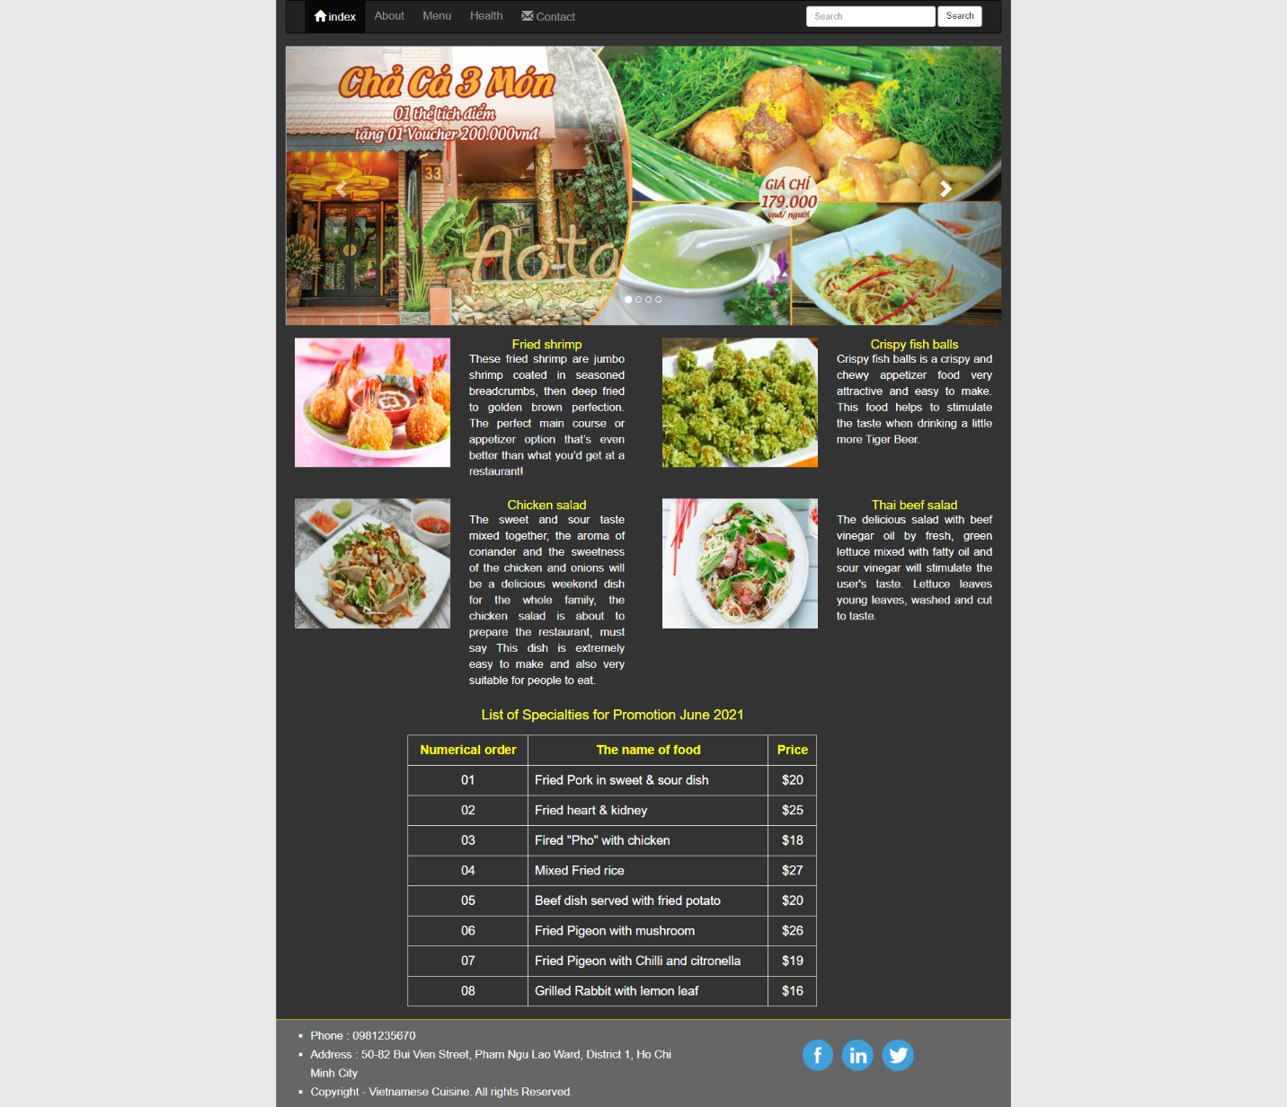

**The end**